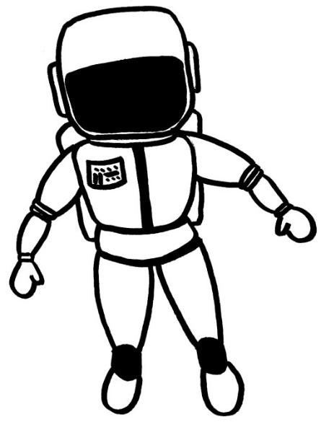
October 2016
Dear Families,
My name is Tracey Bean, and I am the gifted teacher at Werner Elementary. And I have to admit that I have a problem – a good one though! I like writing grants. Two years ago, I wrote a grant and received money from Honeywell and NASA to attend Educator Space Camp in Huntsville, Alabama. While there, I spent the week learning about being an astronaut (and having FUN!) A good portion of the week we were completing STEM (Science, Technology, Engineering and Math) challenges. While I was there, I just kept thinking about how fun it would be to modify these challenges to bring home to my classroom.
Last October, I decided to write another grant (or two!) that would this time benefit the students and give me the funding to bring back the ideas I had at Space Camp. Thanks to Toshiba and our local Rotary club, we are bringing engineering challenges to all of the 3rd, 4th and 5th grade students at Werner during math classes. These monthly engineering projects (mostly space related) allow kids to learn about collaboration, designing, testing, and redesigning using their creative and mathematical skills. We will begin our first challenge in October with three more during the year.
We will need your help! If there are any of you that would want to volunteer time to help or you also have a passion for engineering and the design process, please let your child’s homeroom teacher know. Challenges will take place on Thursdays and Fridays during regularly scheduled math times on the designated days. We can always use more hands! If you can’t help one month, there will be more opportunities during the year. Stay tuned for information from your child’s math teacher about details on signing up to help.
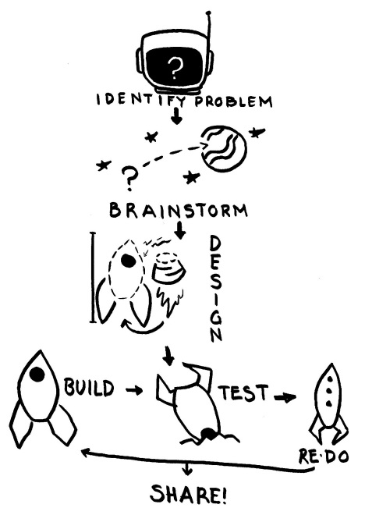
Please let us know if you have any questions or if you are available to help. Looking forward to seeing what fabulous ideas are generated!
Sincerely,
Tracey Bean & the Werner 3rd, 4th, 5th grade teachers
tbean@psdschools.org

